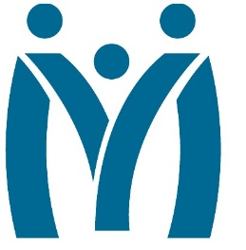

Metropolitan Human Services District
Board of Directors Meeting
June 24, 2022|12:30pm

3100 General DeGaulle Drive, New Orleans, LA 70114 – Large Conference Room
MHSD fulfills its statutory role as the planning body for the behavioral health, addiction and intellectual/developmental disability services for the residents of Orleans, Plaquemines and St. Bernard Parishes by ensuring that eligible residents in these parishes have access to person centered and recovery focused supports designed to optimize their role in the community.
Agenda

Call to Order

Approval of the March 30, 2022 Minutes

Monitoring Reports

Monthly Dashboard & Telehealth Report (postponed for next meeting)

Fiscal Report: FY 21 Analysis as of May 31, 2022

June Reports:

Budget Review

Executive Director Report

Decision Information

Officer Elections/Board Training

Approval of Contracts over $300,000

Consent Agenda

Self-evaluation: Board Performance Review

Adjourn

